Are you pitch-slapping your way to clients? Stop, right now!
By Praveen Singh
Founder, StrategyVerse Consulting LLP
Hey readers, do you want to know how to generate publicity without spending money? If yes, get in touch with us. I am sharing our credentials here for your reference.
If you read the above paragraph wondering what the hell is this, know that I have just pitch-slapped you. Did it hurt? I am sure it did. It hurt because you did not come here to read a sales pitch. You came here to read an article about business development and how to avoid the pitfalls of sending a blind pitch to your target customers.
Pitch-slapping is when you send a sales pitch to somebody you just connected with (or even before connecting). The recipient is expecting a value-based engagement but ends up receiving an unsolicited sales pitch. It happens all the time on social media and it hurts the recipient every time.
Gone are the days when B2B buyers used to explore sales pitches from people they didn’t know. Today, people buy from people they know and trust. They prefer discussing their requirements with and eventually buy from people who have a social proof as an expert. It is just simpler that way. It helps them take better decisions by removing all the distractions from their buying ecosystem and focusing on a few key players.
Unfortunately, most sellers still prefer sending cold sales pitches. Many reach out to buyers on social media, email or Whatsapp and send these pitches, praying they get a response. It doesn’t surprise me that the average response rate to cold pitches is 1-5%. Some may say this is a good response rate, but I disagree.
I prefer fewer sales pitches with close to 100% response rate. It gives a better return on efforts. You don’t want to invest your time to send pitches to 1000s but only get on a call with a handful of your prospects. You would rather want to gain their trust from day 1 and take all of them through the buyer’s journey successfully.
If you are rolling your eyes and asking is this even possible, let me tell you it is. All you need to do is be intentional about helping your prospect, rather than reaching out to them as part of your pre-decided sales motion. Being intentional here involves the following steps:
- Know your prospect: Create your ideal customer profile (ICP). Saying that we cater to companies of all sizes and industries is saying you don’t know your ideal customer profile. Every business can serve all kinds of companies but it makes sense to identify a segment to start with. It helps in engaging with them deeper. You can always add more ICPs as your business grows.

- Research about their requirements: Once you know your ICP, it is easier to find out about their specific requirements. For example, if you provide PR services to Series-A startups, you know they are in growth phase and would look for PR agencies with pan-India presence. Some may also ask for international presence. This knowledge will help you in creating appropriate collateral to share with prospects when the time comes.

- Engage with them socially and provide value: Social media like LinkedIn, Twitter, Reddit, etc. are goldmines for people who have clarity about their ICP and their business requirements. These channels are waiting to be leveraged. All one needs to do is interact with their target customers by posting original content and commenting on other’s posts. The idea should be to educate, inspire, entertain and persuade the target customers. Doing this will make them curious to know more about how you can help them achieve their target.

- Create a social proof: Besides engaging with your target customers, you should also create a repository of testimonials, case studies, whitepapers, concept notes, and blogs to showcase your knowledge and skills. This will enable the potential client to check your credentials and know you better before engaging with you further.
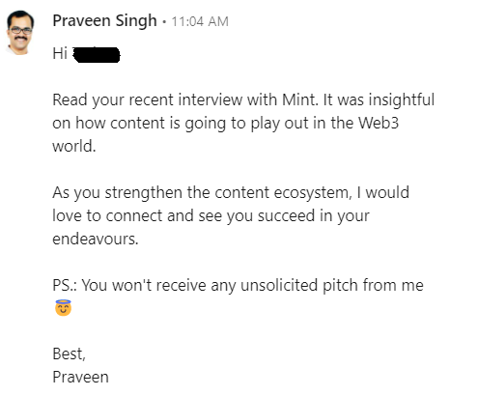
- Get into DM or seek a call: The next step in the engagement cycle is to start an exclusive conversation with your identified prospective clients. Again, this can’t be a plain request for a call or booking a demo. Rather, you have to connect with them without talking about your business. If you have been engaging with their posts earlier, they would recognise you and would like to engage in a conversation. In my experience, many people start a business conversation on their own. Here’s an example:
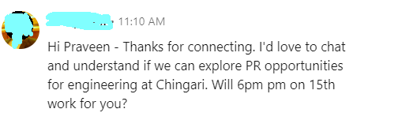

Your prospective clients are on social media for business networking, after all, and if they feel you could be of help to them, they would seek your help.

- Ask pertinent questions: The target clients seldom have a clear idea about how to reach their publicity goal. Most would say “we want to be known as a disrupter in our industry” or “we want our coverage in The Economic Times or The Times of India”.

But what is the route to reach there? Do they have enough meat in their story to get those coverage? Are they ready to take necessary action to get there? Does their target audience read those publications at all? Asking these questions enable the target clients to understand what exactly they need to do.

- Send a customised offer: If you and the prospective client are aligned on publicity goals and the roadmap to reach there, it is time to send a customised proposal. A universal proposal does not work because each client has different needs.
Conclusion: Taking these steps needs persistence and patience but doing it is the best available option if you want a friction-less inflow of business. The alternative option is to continue pitch-slapping your prospect and remain one of the many ignored brands in their email and DM.

